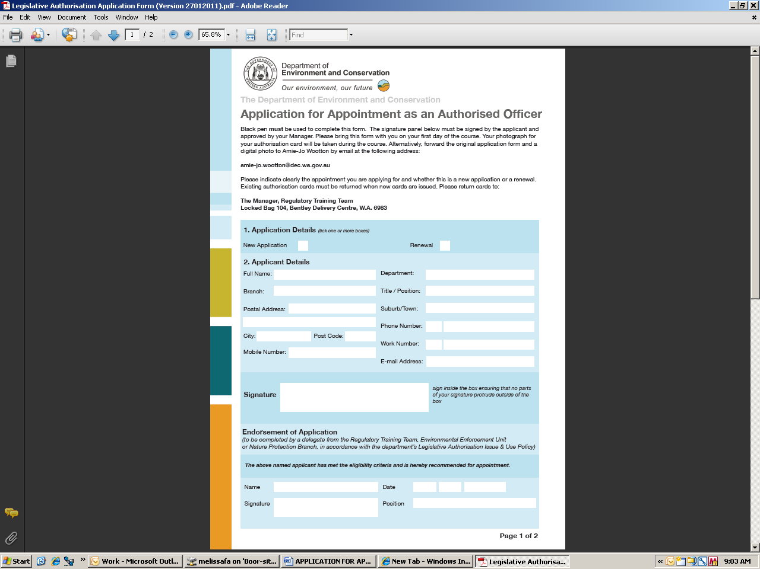


Application for Appointment as an Authorised Officer

A digital photograph of the applicant must be emailed to pollutionwatch@dec.wa.gov.au by the applicant’s manager, with a statement verifying the photograph is a true image of the applicant. A scan of this completed form should accompany the photograph. The original form must be mailed to:
Environmental Hazards
Locked Bag 104
Bentley DC WA 6983

Black pen must be used to complete this form.

- Application Details

New Application |  | Renewal
If renewal please fill in CURRENT card number

Existing Cards must be returned when the renewal is received
- Applicant Details

Full Name:

Local Government:

Title/Position:

Postal Address:

Suburb: | State: Postcode:
Work Number:

Mobile Number:

E-mail Address:

Signature: | Sign inside the box ensuring  that no parts of your signature  protrude outside of the box
- Details of Relevant Training (for new applicants or amended appointments only)
Date of DEC environmental regulatory officers inspection course:
Date of noise regulations course (or Curtin Uni. Equivalent):
Date of Unauthorised Discharge Regulations training course:
Date of Dumping Waste (s49A) EP Act
Duration of above (Two day or half day):
Relevant qualifications:
Relevant enforcement experience:

- Appointment Being Applied For
Inspector & Authorised Officer |  | Local Government Applicants Only  Noise Pollution Only (N1)  Noise and Other Pollution (P1)
- Approval (to be completed by Local Government CEO)

Name:  Signature: |  | Position:  Date:
Office Use Only  Photograph Attached YES NO  ID number |  | Date Received  Date Issued
- Endorsement of Application (to be completed by a delegate from the Environmental Hazards Branch in accordance with the department’s Legislative Authorisation Issue & Use Policy)
The above named applicant has met the eligibility criteria and is hereby recommended for appointment

Name:  Signature: |  | Date:  Position:

